Webquest - Photosynthesis and Cellular Respiration

Photosynthesis Review
Go to http://goo.gl/YWtj2
Start the animation.
- Photo = Synthesis =
Answer questions 2 and 3 before clicking and dragging the pictures into place.
- What four things are needed for a plant to complete photosynthesis?

- What two things are produced by a plant during photosynthesis?

- What is the photosynthetic equation? The equation given contains matter only.

____________________ + ___________________ → _______________________ + _____________________

- What is missing from the equation above?
- Where is chlorophyll stored?
- Label the following picture. Use these words: upper epidermis, pith, phloem, lower epidermis, guard cells, stomata, xylem, cuticle, chloroplasts.

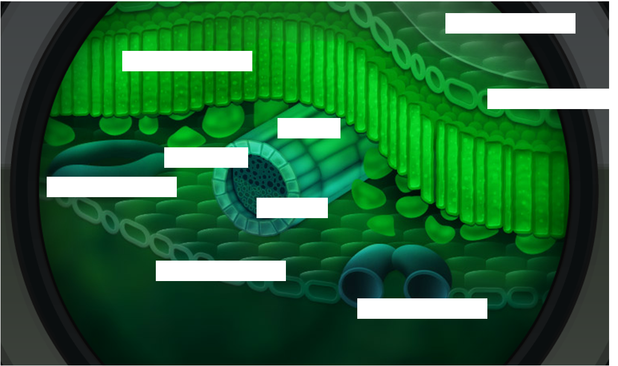

Cellular Respiration Review
Go to https://www.youtube.com/watch?v=4Eo7JtRA7lg&vl=en
Start the animation.
- What process do humans rely on for energy?
- What organisms must do cellular respiration?
- What is the input (reactants) of cellular respiration?

- What is the output (product) of cellular respiration?

- Write the full equation for cellular respiration?

________________ + ______________ → _____________ + _______________ + _________________

- How are photosynthesis and cellular respiration similar? Talk about the reactants (input) and products (output) of each equation.

- During these processes (cellular respiration) ______________ molecules, such as glucose, are gradually broken down and their energy is used to produce ____________.

Photosynthesis and Cellular Respiration
Go to http://goo.gl/wy6Q5n
Watch the video.
- About 60% of the food you eat is _________________________________________.
- Carbohydrates contain ___________________________, ___________________________, and _______________________.
- What source of energy helps the plant split oxygen?

- Photosynthesis produces glucose. The glucose is then used to build bigger and better carbohydrates like _________________________________ and _________________________________.

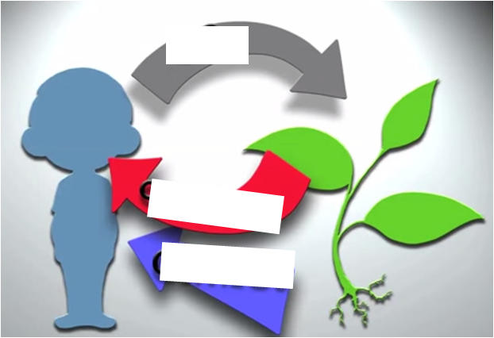
- Explain how humans benefit from photosynthesis.

- Why do we have to turn glucose into ATP?

- How are ATP and dollars similar?

- Even plants have _____________________________ to break down the glucose they make into __________.
- Fill in the diagram to the right.

Gizmo - Plants and Snails
Go to http://www.explorelearning.com/
Follow your teacher’s instructions for logging in and finding the Gizmo.

Introduction: In this Gizmo, each test tube contains a small amount of bromthymol blue (BTB). BTB is an indicator that changes color in the presence of carbon dioxide. If carbon dioxide is present, the indicator will turn a yellowish color. You will be placing plants and snails into the test tubes and observing what happens.

Answer questions 1 and 2 before starting the Gizmo.
- What important gas do we take in when we breathe?

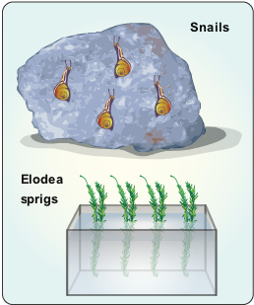
- Why don’t we run out of the important gases that we need to stay alive?

With the lights set to on, drag a snail into one test tube and a plant into another. Press play ().
- After 24 hours, what is the color of each tube?

Select show oxygen and CO2 values. Place the probe in each tube. The probe will show you the levels of two gases, oxygen and carbon dioxide.
- When the water turns blue, which gas is most common?

- When the water turns yellow, which gas is most common?

- What does it tell you when the water is green?

Activity A:  Gases in and gases out | Get the Gizmo ready:  - Click Reset ().  - Clear all of the test tubes.  - Turn on Show oxygen and CO₂ values. | 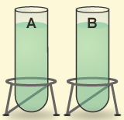

Place a snail and sprig of Elodea in two different test tubes. Turn the lights on and press play.
- What gas do plants give off in the light?

- What gas do animals give off in the light?

Click reset, turn the lights off, and press play.
- What gas do plants give off in the dark?

- What gas do animals give off in the dark?

Fill in the blanks.
- Animals breathe in ________________________ and breathe out __________________________.

- In sunlight, plants take in ___________________________ and release __________________________.

Activity B:  Interdependence | Get the Gizmo ready:  - Click Reset.  - Clear all of the test tubes.  - Turn the light switch to on.  - Check Show oxygen and CO₂ values. | 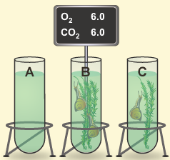

Put one sprig of Elodea and one snail in a test tube together with the lights on. Click play.
- Does the color of the water in the tube change?

- What happens to the oxygen and carbon dioxide levels?

Without using the Gizmo, predict what you think will happen to the gas levels in each case listed below. (Only fill in the Prediction column, leave the Actual Result column blank for now.)

Tube | Prediction | Actual Result
2 snails, 2 sprigs,
lights on
1 snail, 2 sprigs,
lights on
1 snail, 2 sprigs,
lights off

Now run the Gizmo and fill in the Actual Result column in the table above.
- Describe how plants and animals each contribute to the survival of the other.

