Constructing a DNA Model Coding for your Name! | 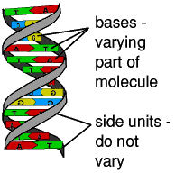
DNA is a complex molecule found in all living things. Constructing a DNA model is a great way to learn about DNA transcription and translation. DNA carries the codes for all the proteins that make up organisms. Its structure is that of a twisted double helix composed of linked nucleotides made of sugars, phosphates, and nitrogenous bases (adenine, thymine, guanine and cytosine).
The base code sequences (genes) DNA carries are used to form chains of amino acids. As all brilliant CHON know, amino acids are the monomers that form the primary structure of the polymer, protein. RNA must first transcribe (make a copy) of the section of DNA (gene) in the nucleus that codes for the particular protein needed. After the code is transcribed, the protein can be translated (built) by ribosomes in the cytoplasm. This project will introduce you to protein synthesis, the process that transcribes and translates the language of DNA into the language of proteins: the sequence of amino acids that form the primary structure of proteins. Happy learning!
Objectives:
- Students will learn the structure of the four nucleotides making up DNA
- Students will be able to produce part of a DNA model
- Students will demonstrate understanding of transcription by using Genetic Code to encode their name into the DNA molecule.
- Students will demonstrate understanding of translation through determining the amino acid sequence that could be made from their DNA model.
Possible Materials (your choice):
- The basic subunits of DNA
- Beads, pipe cleaners, string, marbles, electrical tape, wired ribbon, etc.
- NO STYROFOAM!
- Colors (red, green, yellow, blue, black, & purple)
- Scissors
- Glue &/or tape
- Pencils/pens/markers
- String/wire
Procedure:
PART A - Building DNA
- Construct all of the units needed to make the nucleotides from a single strand encoding your name.
- Color code the Nitrogenous bases, phosphorus, and sugars: Adenine (Blue), Guanine (Green), Thymine (Yellow), Cytosine (Red), Phosphate ((Purple) and Deoxyribose(Black).
- Construct a NUCLEOTIDE by gluing or taping a phosphate, sugar, and one base together (see Diagram 1)
- Finish constructing the other nucleotides, and give your model a “TWIST” so that it resembles a double-helix!
BASE PAIRING RULE For DNA:
A pairs with T
C pairs with G
- Use a single strand of your nucleotides to make the LEFT STRAND of your DNA model by taping the phosphates of ONE nucleotide to a deoxyribose sugar of ANOTHER nucleotide. 5’ should be at the top, 3’ at the bottom of the strand.
- When you have completed the left side of your model, RECORD the BASE SEQUENCE starting with the TOP base in Table 2.
- Use your other nucleotides to construct the COMPLEMENTARY RIGHT STRAND of DNA (A with T and C with G). 3’ should be at the top, 5’ at the bottom of the strand.
- Record the sequence of your Right Strand in Table 2.
- Your model of DNA should look like a ladder.
- Attach an unfolded paper clip to your DNA model for hanging from the ceiling.

TABLE 1
Nucleotide Component | Quantity | Color
Thymine |  | YELLOW
Adenine |  | BLUE
Cytosine |  | RED or Pink
Guanine |  | GREEN
Phosphate |  | Purple or Lavender
Deoxyribose Sugar |  | BLACK

Diagram 1
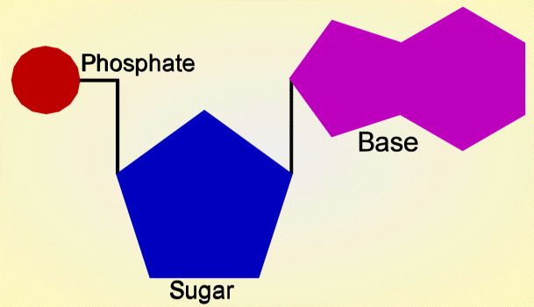
Table 2
Base Sequence LEFT Strand | Base Sequence Right Strand
Conclusion:
1. Name the 4 DNA nucleotides.
2. What 2 molecules make up the sides of DNA.
3. Your DNA model appeared ladder-like. What is the true shape of a DNA molecule?
4. Where in a cell would you find DNA?
5. If 25% of DNA is Adenine, what percent is Cytosine?
6. What would happen if RNA made mistakes when it copied DNA's instructions?
Name____________________________

DNA Project Rubric

Use the samples and this rubric as a guide to make sure your project is done correctly.

__________ Title of Project, Shows Ownership (5 points)

__________ Key with mRNA codons clearly indicating your name (15 points)

__________ Base sequences correctly spell out your name (10 points)

__________ Complementary core of bases clear (10 points)

__________ Alternating deoxyribose/phosphate backbone (10 points)

__________ Base pairs connect to deoxyribose (10 points)

__________ 5’direction and 3’ direction are clear (10 points)

__________ Can assume double helix shape (10 points)

__________ Hydrogen bonds joining base pairs (10 points)

__________ PAP level work (10 points)

__________ Total Points earned out of 100

